Capstone Project Design: A Payment System

Makayla Baker
Cambrian College
IOT-1026: Object Oriented Prog
Evan Poitras
April 2, 2026

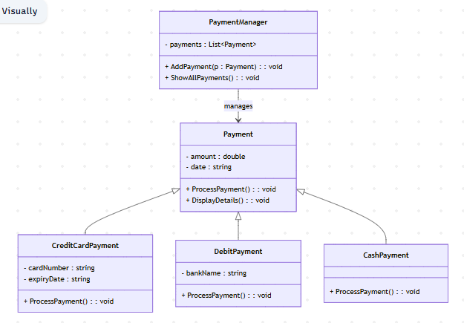
Description: This program is a simulation that allows users to use a payment system with three different options of payment. You can use credit card, debit card or cash payment. The goal for the program is that users can simulate payment using different forms of payment while also using object orientated programming concepts! This program solves the problem of organizing and handling different types of payments in a structured and effective way.
What the program features:
- Select a payment, Cash, debit or credit
- Enter payment details such as the amount + required information
- Process the payment
- View details of the payment
- Store multiple payments and display them
Use of OOP:
- Classes: Each part of the system is represented by a class- Payment, CreditCardPayment, Debitpayment, CashPayment, PaymentManager
- Objects: The program creates objects from these classes to represent individual payments.
- Inheritance: The CreditCardPayment, Debitpayment and CashPayment classes inherit from the base Payment class. This allows shared properties and methods while also customizing behaviour.
- Encapsulation: Each class contains its own data and methods, which keeps the program organized.

